Invitation for Bid/Specifications
Xerographic Paper
115
11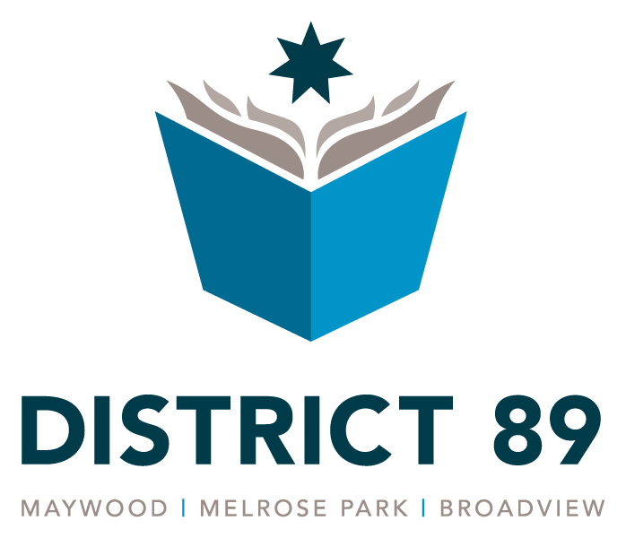

Maywood-Melrose Park-Broadview
School District #89
906 Walton Street
Melrose Park, IL 60160
October 10, 2019

Bid Instructions

- Bids are to be submitted on the District #89 “Bid Form” that is attached.

- No bids will be considered if they arrive after the due time of 10:00 A.M., October 22, 2019 at 906 Walton Street, Melrose Park, IL 60160.

Bids are to be addressed to:

Maywood-Melrose Park-Broadview School District 89
Administrative Offices
Attention: Raymond Lauk, Business Manager
906 Walton Street
Melrose Park, IL 60160

- All packages must also be marked “Copier Paper Bid – DO NOT OPEN”

- Platform delivery only to: 1133 S. 8th Avenue, Maywood, IL 60153

- Skid size must be 36” x 47” with no overhanging material.

- Bid will include shipping charges on a separate line on bid form.

- Advance notice of the exact delivery time must be given to Clarence Thomas (708/670-0202), with no Saturday, Sunday or holiday deliveries or deliveries after 3:00 pm.

- The Board of Education reserves the right to accept or reject any portion and/or total of each bid proposal.

- No other costs will be paid other than those that are disclosed on the “Bid Form”.

- Certificate of Insurance must be provided 5 business days after bid award and before any products are delivered. The following will be minimum coverages:

Worker’s Comp = $1,000,000
Comp Gen Liability= $1,000,000/Occurrence
$2,000,000/Aggregate
Automobile=$1,000,000
Umbrella=$5,000,000/Occurrence
$5,000,000/Aggregate
- Certificate of Compliance with Drug Free Workplace Act (Copy Attached)

- Non Collusion Affidavit (Copy Attached)

- Bid Rigging Certification (Copy Attached)

- Delivery will be in two (2) shipments to 1133 South 8th Avenue, Maywood, IL. You must contact Clarence Thomas, Supervisor of Buildings and Grounds, at 708/670-0202 to arrange deliveries. The first delivery, half the quantity of each item specified in the bid, must be delivered the week of December 2, 2019. The second delivery for the remaining quantity must be delivered during the week of July 20 2020.

- Please direct any questions to Raymond Lauk, Business Manager,-708/450-2896.

Bid Proposal Form
This form must accompany the bid Pages.
I have carefully examined the instructions and specifications. If awarded a contract within 30 days, I agree to furnish all the items bid here and agree to sign all the other documents requested. I also verify that I am an officer of the bidding company.

By :________________________________________________________________
Signature

Print Name & Title:____________________________________________________

Company:___________________________________________________________

Address:____________________________________________________________

City/State/Zip:________________________________________________________

Direct Telephone Number of Signature:____________________________________

Maywood, Melrose Park, Broadview School District 89

Vendor Name: _ _________________________________________________

Vendor Address:________________________________________________

_______________________________________________________________

Bid Opening Date: October 22, 2019, 10:00 am

20 lb. 8.5 x 11 White Long Grain, 500 sheets per ream. Weight 10M, LNT free to prevent clogging, precision cut to avoid jams, moister content low to prevent paper curling. 84 Brightness, 89 Opacity with Blue/White dye.

50 sheets as a sample of the paper being bid must be provided.

Item Quantity Unit Price Quantity Price

1. White Bond Paper 20,000 reams $__________ $___________

Xerographic, for use

especially with high

speed copiers and

Printers 8.5” x 11”

2. White Bond Paper 0 reams $__________ $___________

Same as above.

8.5” x 14”

3. White Bond Paper 0 reams $__________ $___________

Same as above.

11” x 14”

4. Six different color 1,180 Reams $__________ $___________

Bond Paper same as (1,180 consists of: 230 Blue, 230 green, 30 yellow, 230 pink, 230

above. Blue, Green, buff and 230 goldenrod)

Yellow, Pink, Buff

Goldenrod. 8.5” x 11”

Delivery Charges $___________

CERTIFICATE OF WORKING CONDITIONS
CERTIFICATION OF COMPLIANCE WITH DRUG-FREE WORKPLACE ACT

The undersigned, having 25 or more employees, does hereby certify that pursuant to section 3 of the Illinois Drug-Free Workplace Act (30 ILCS 580/3) that it shall provide a drug-free workplace for all employees engaged in the performance or work under the contract by complying with the requirements of the Illinois Drug-Free Workplace Act and, further certifies that it is not ineligible for award of this contract by reason of debarment for a violation of the Illinois Drug-Free Workplace Act.

Name of Bidder (Please Print)

Submitted by (Signature) Title

SUBSCRIBED AND SWORN (or affirmed) TO BEFORE ME THIS _______________ DAY OF

_______________________, 20___.
_____________________________________OFFICIAL SEAL:
(Notary Public)
My commission expires:

____________________________________________________

NON-COLLUSION AFFIDAVIT
((STATE OF ILLINOIS) SS.COUNTY OF ______________________________)
The undersigned contractor or agent, being duly sworn, on oath that he/she has not nor has any other member, representative, or agent of the firm, company, corporation or partnership represented by him/her, entered into any combination, collusion or agreement with any person relative to the price quoted by anyone at such letting, not to prevent any person from quoting nor to induce anyone to refrain from quoting, and that his/her quotation is made without reference to any other quotations and any agreement, understanding or combination with any other person in reference to such quotation.
He/she further says that no person or persons, firms, or corporations has, have or will receive directly or indirectly, any rebate, fee, gift commission of thing of value on account of such contract.

______________________________________ _____________________________
Name of Bidder Signature
FOR:
____________________________________________________________________________
Firm or Corporation Title
SUBSCRIBED AND SWORN (or affirmed) TO BEFORE ME THIS _______________ DAY OF

_______________________, 20___.

_____________________________________OFFICIAL SEAL:
(Notary Public)
My commission expires:

___________________________________________________

BID-RIGGING CERTIFICATION

I, ______________________________________________________________, a duly
(Agent)

authorized agent of _____________________________________________________,
(Contractor)

do hereby certify that neither ______________________________nor any individual
(Contractor)

presently affiliated with __________________________________________ has been
(Contractor)

barred from bidding on a public contract as a result of a violation of either Section 33E-3 (bid-rigging) or Section 33E-4 (bid rotating) of the Illinois Criminal Code, contained in Chapter 38 of the Illinois Revised Statutes.

___________________________________________
Authorized Agent

SUBSCRIBED AND SWORN (or affirmed) TO BEFORE ME THIS _______________ DAY OF

_______________________, 20___.

_____________________________________OFFICIAL SEAL:
(Notary Public)
My commission expires:

____________________________________________________

